**Assignment_03**

1. **What is git-cherry-pick? why we use it?**

If you want to pick any one particular commit from other branch then use cherry-pick with commit id

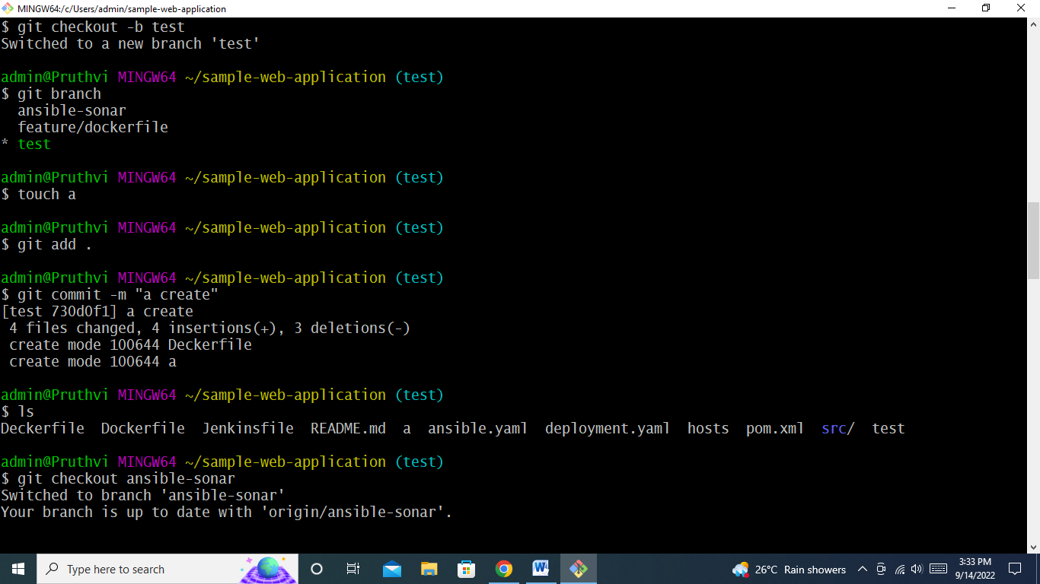

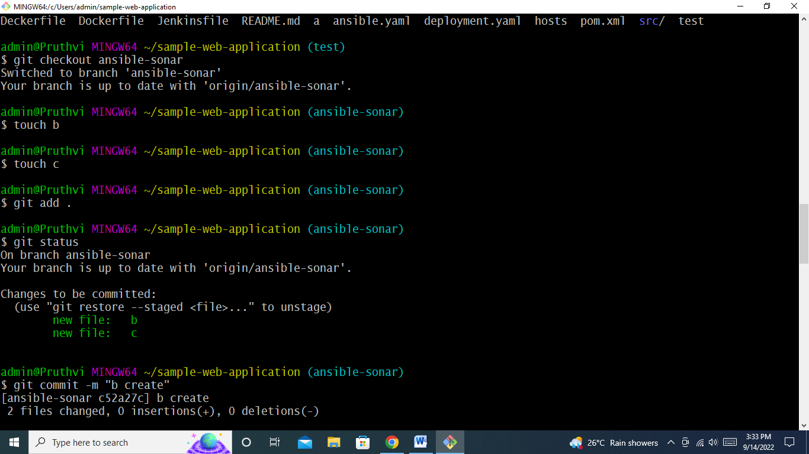

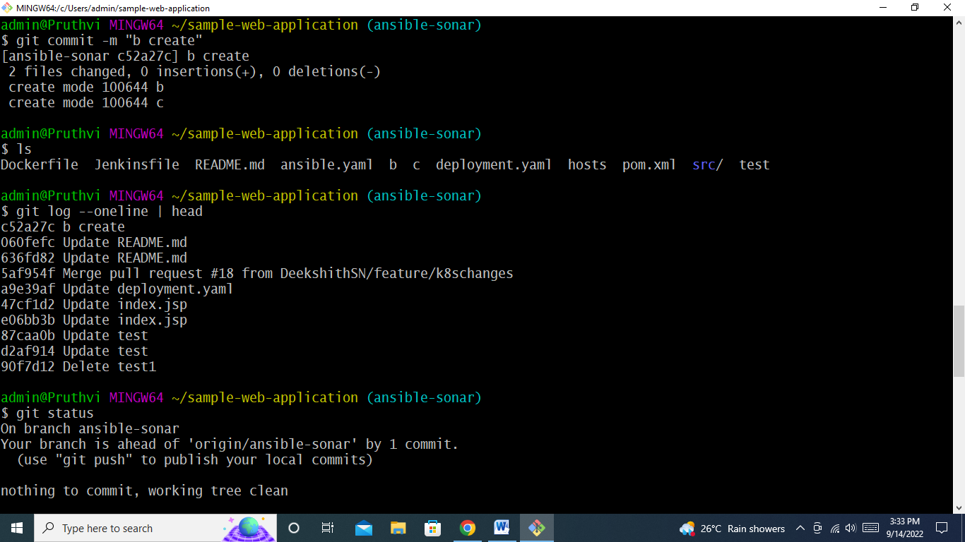

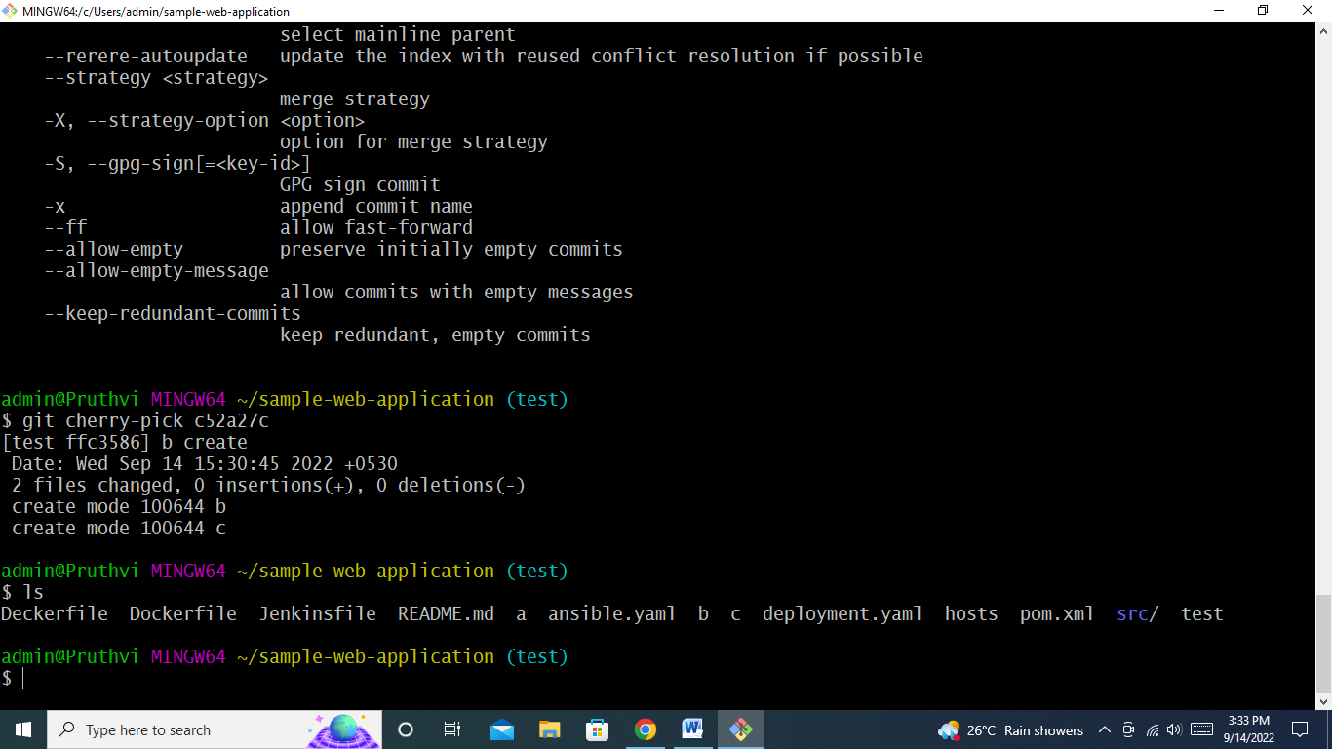

**2. Let’s say you’re working on new feature in some branch, now your manager says stop working on that and change few other things on old code. Here after changing the old code, I need to work on new code, so I need to place my new changes some place How would handle this scenario?**

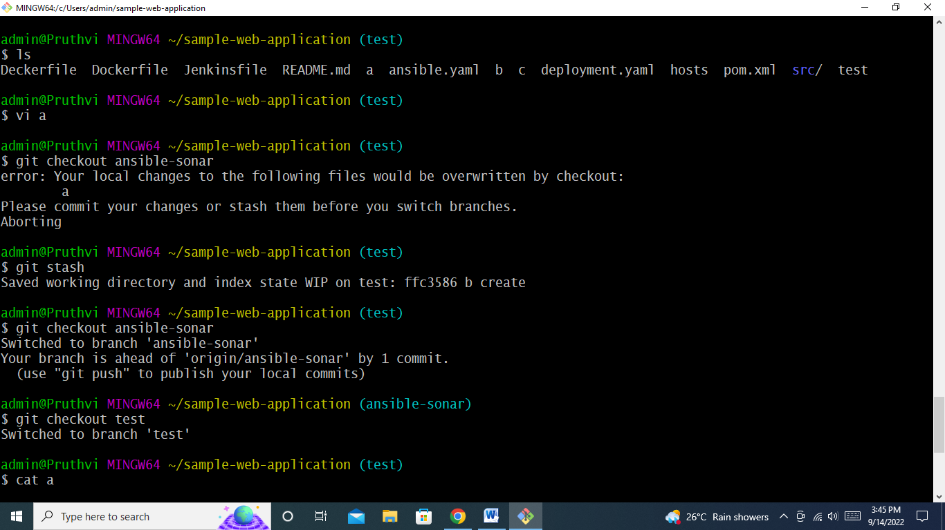

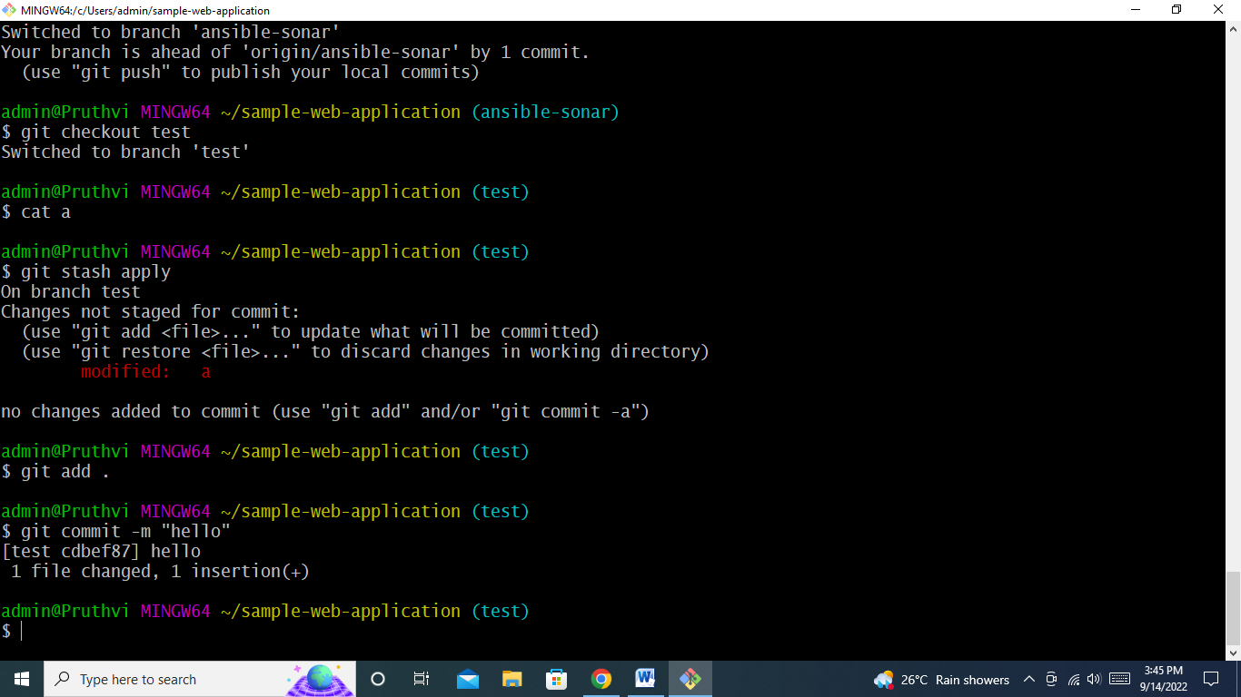

**3. What is a conflict in git?**

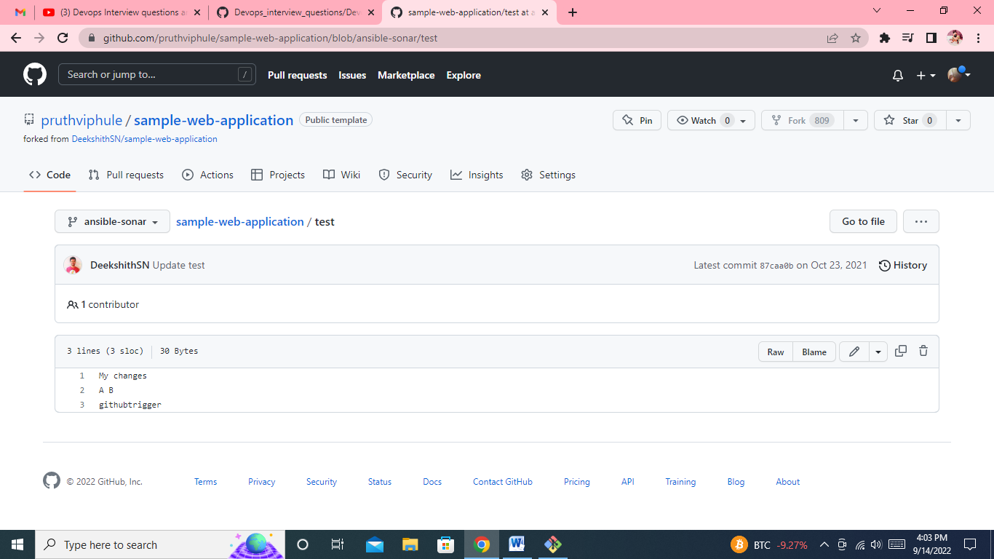

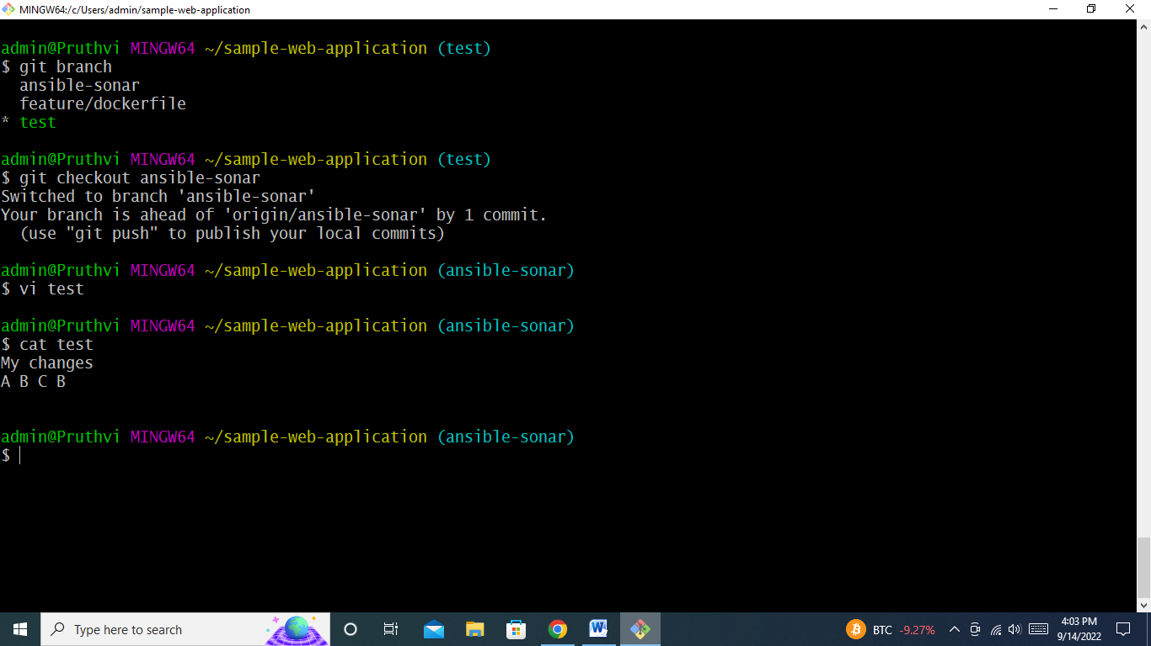

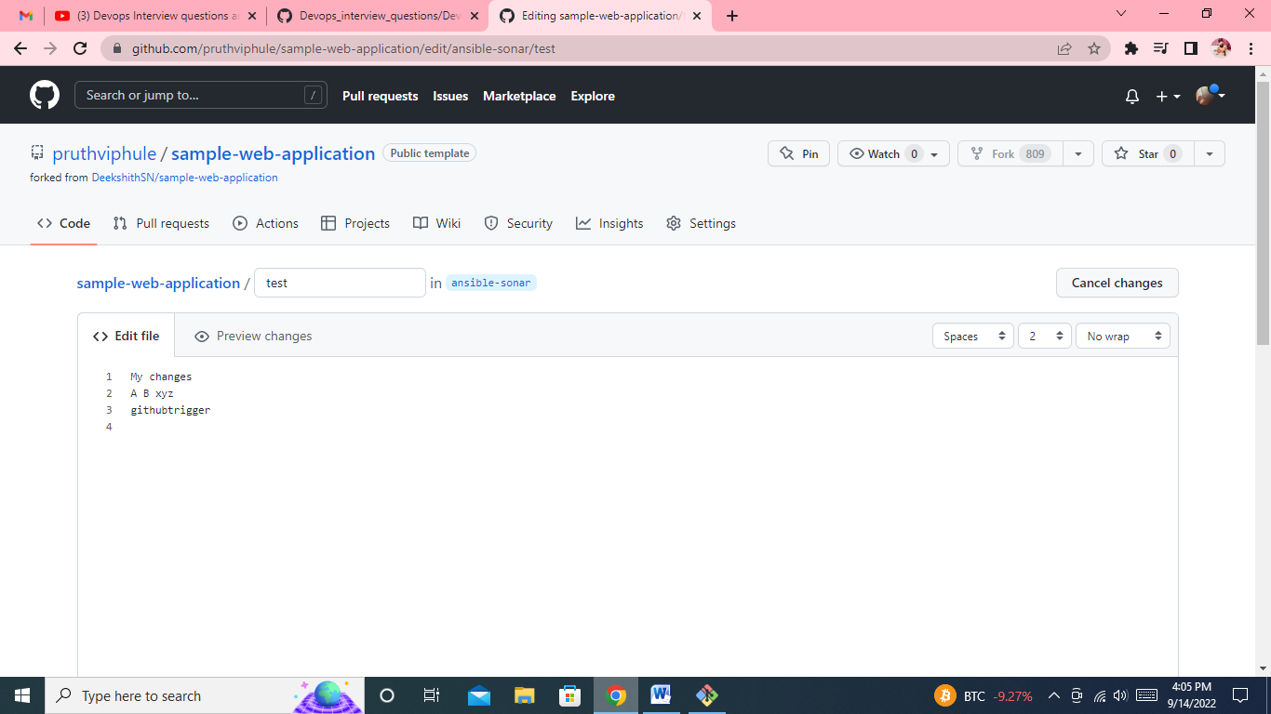

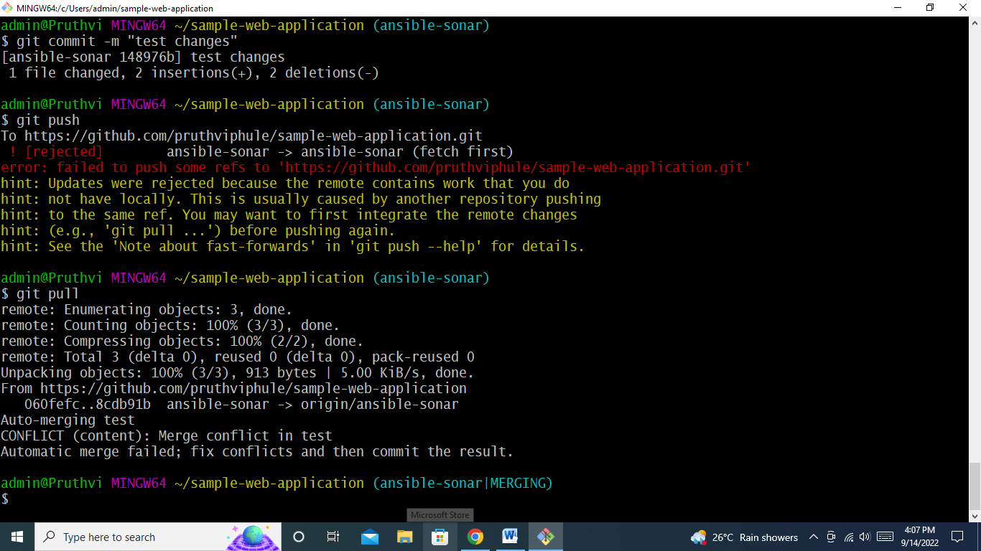

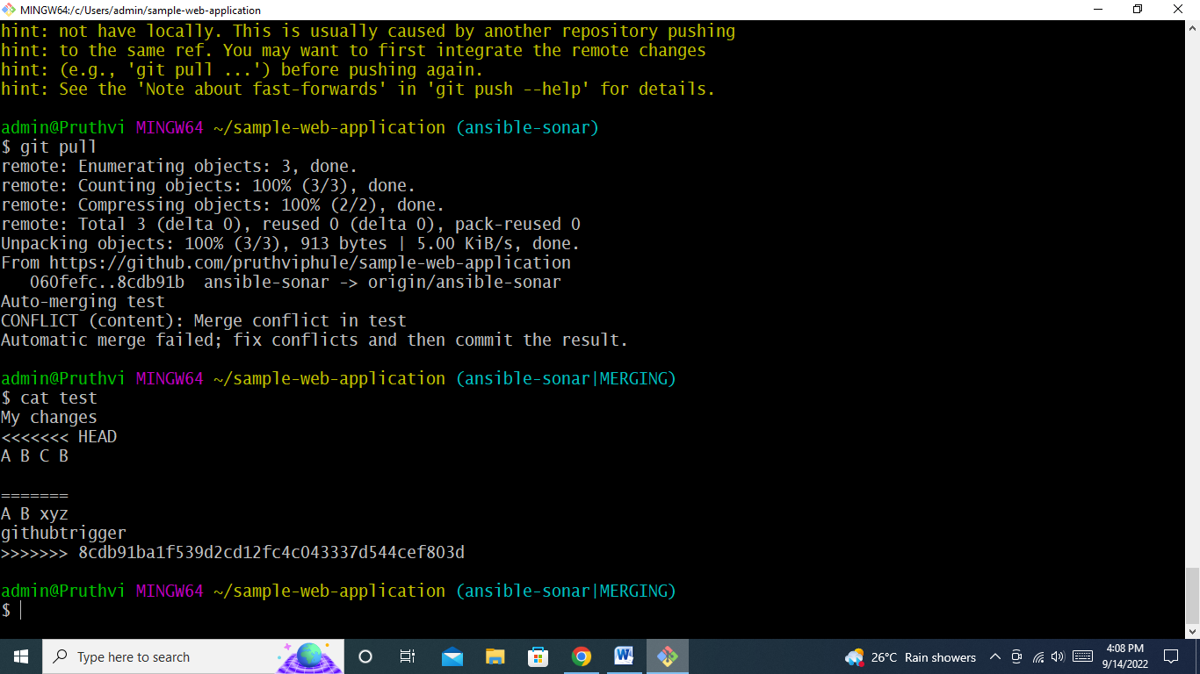

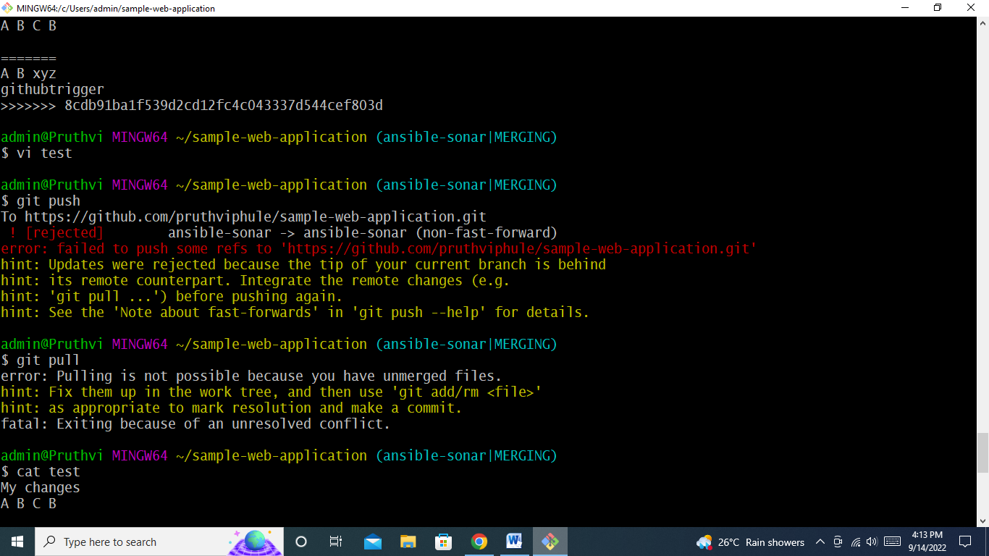

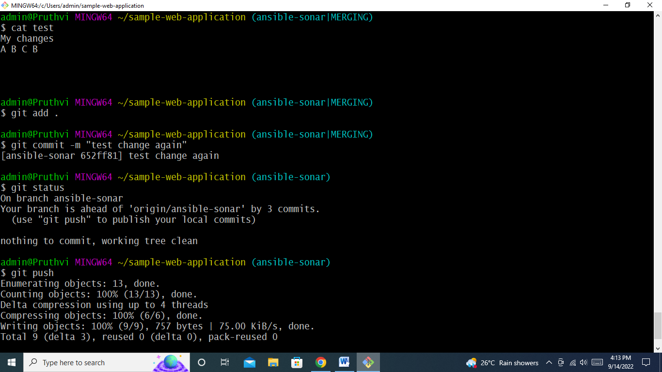

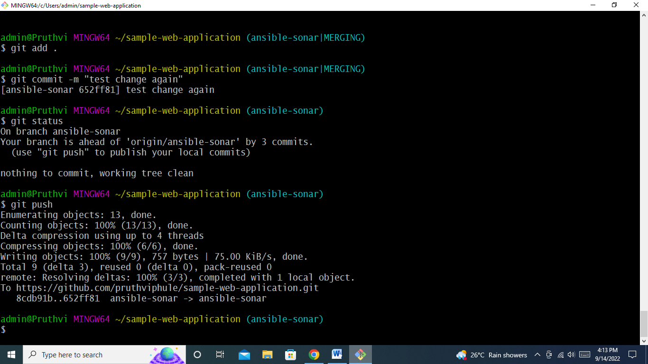

**Maven**

**5 .** **m2 is local repository for maven, now I don’t want to use .m2 folder as my local repository I want to use some other folder as my local, is it possible in maven? If yes, how would you do that?**

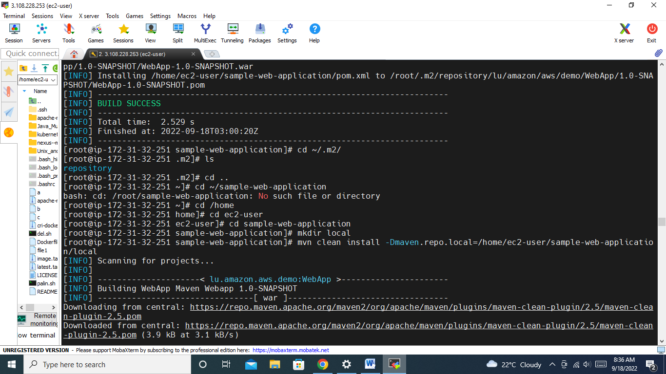

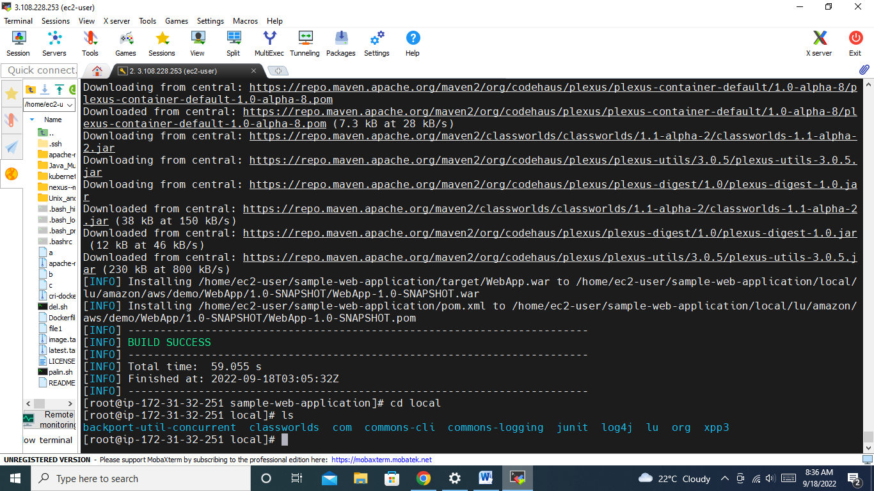

**6.** **maven follows convention over configuration that means it assumes code should be there under src/main/java, test cases under src/tests and many more.Here my requirement is I don’t want to follow that conventions I need to use different folder structure is that possible in maven?**

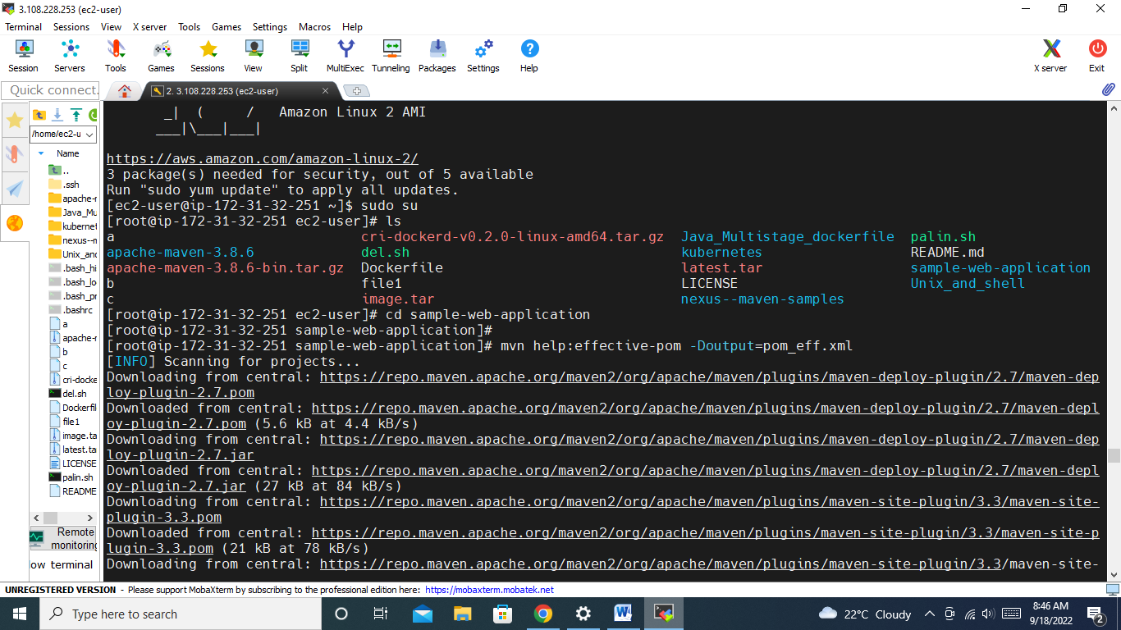

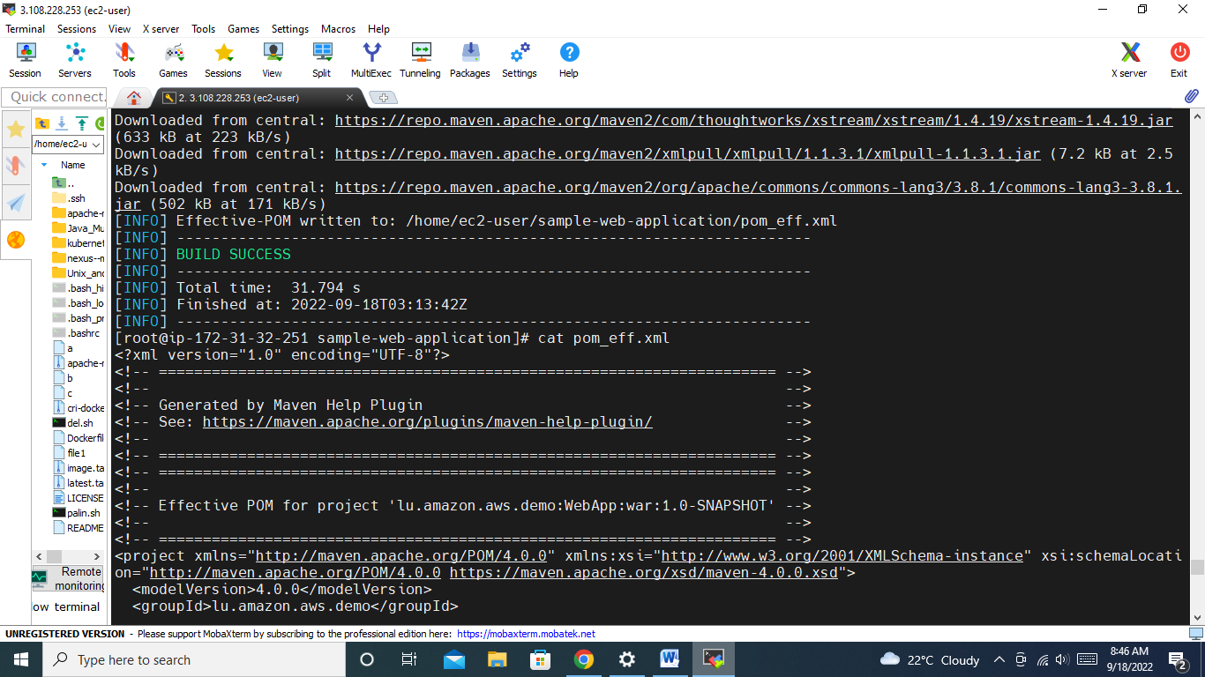

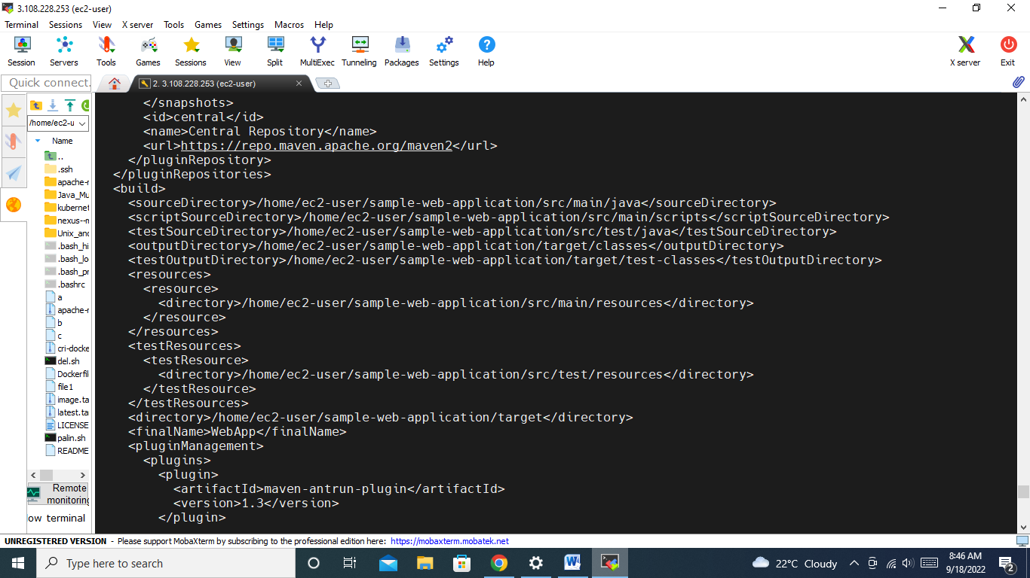

**7. What are dependency and plugin in maven? Give one example for each?**

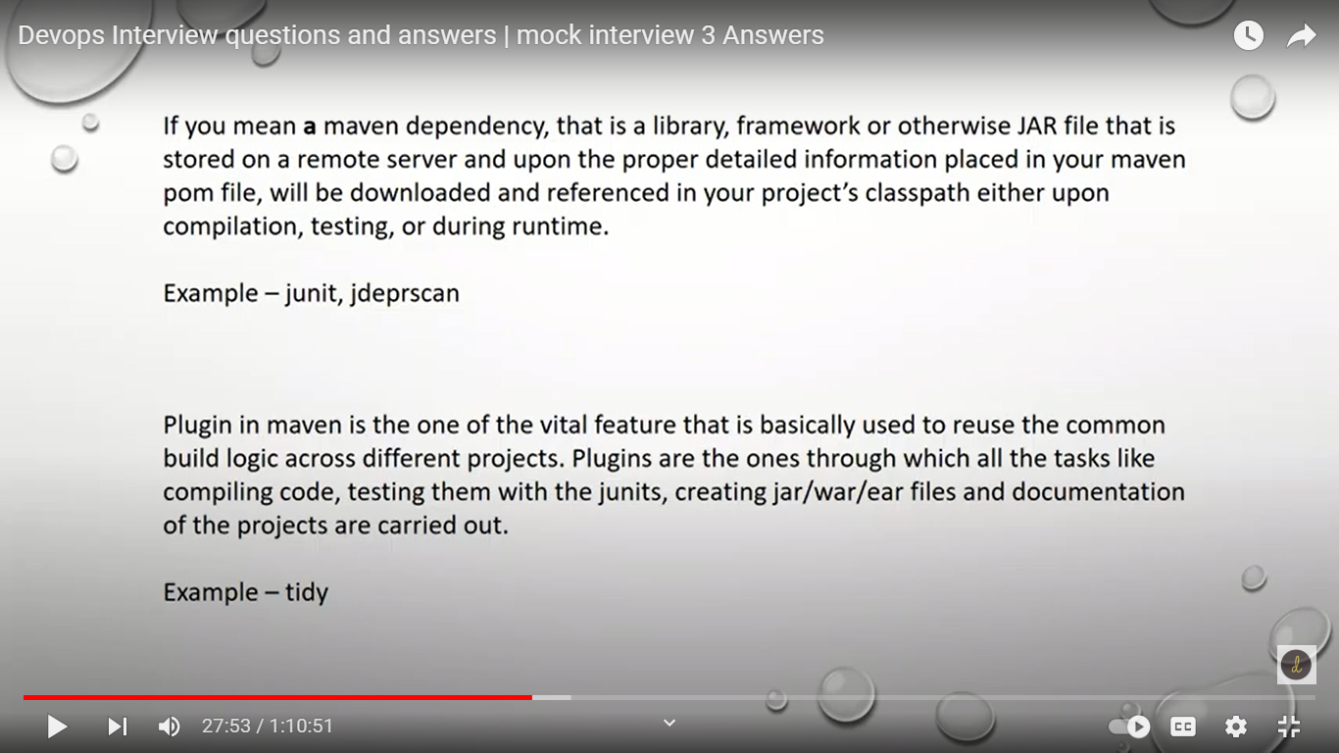

**8. What are 3 build life cycles in maven?**

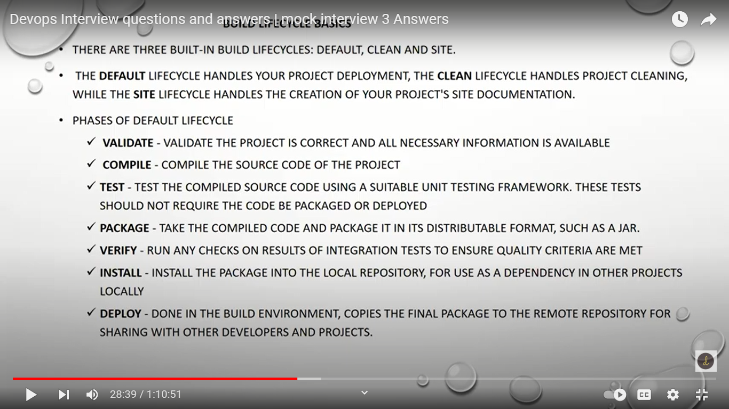

**9. In Which tag we will mention output artifact type( like jar, war or any other)?**

.war - > web application

.jar - > jar application

Default tag – <packaging> jar </packaging>

**Unix and Shell scripting**

**------------------------------------------------------------------------------------**

**12. Lets say I have shell script name magic.sh when I execute. It gives “This is from magic.sh”, so now if I change file name to magic-test.sh I should get “This is from magic-test.sh” basically as name of file chages my output should also change?**

$0 🡪 first parameter - name of the ss file

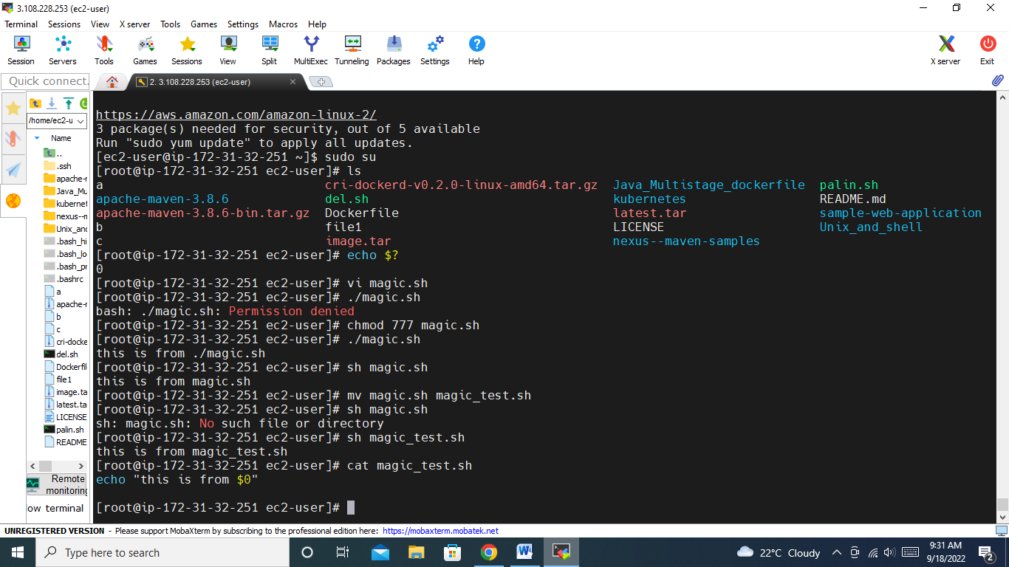

**What is shebang ? Why it is used?**

first line in shell script, which introducing interpreter..

**AWS**

**-----------------------------------------------------------------------------------------------**

**17. What are roles and policies in AWS IAM?**

Policy – list of permissions

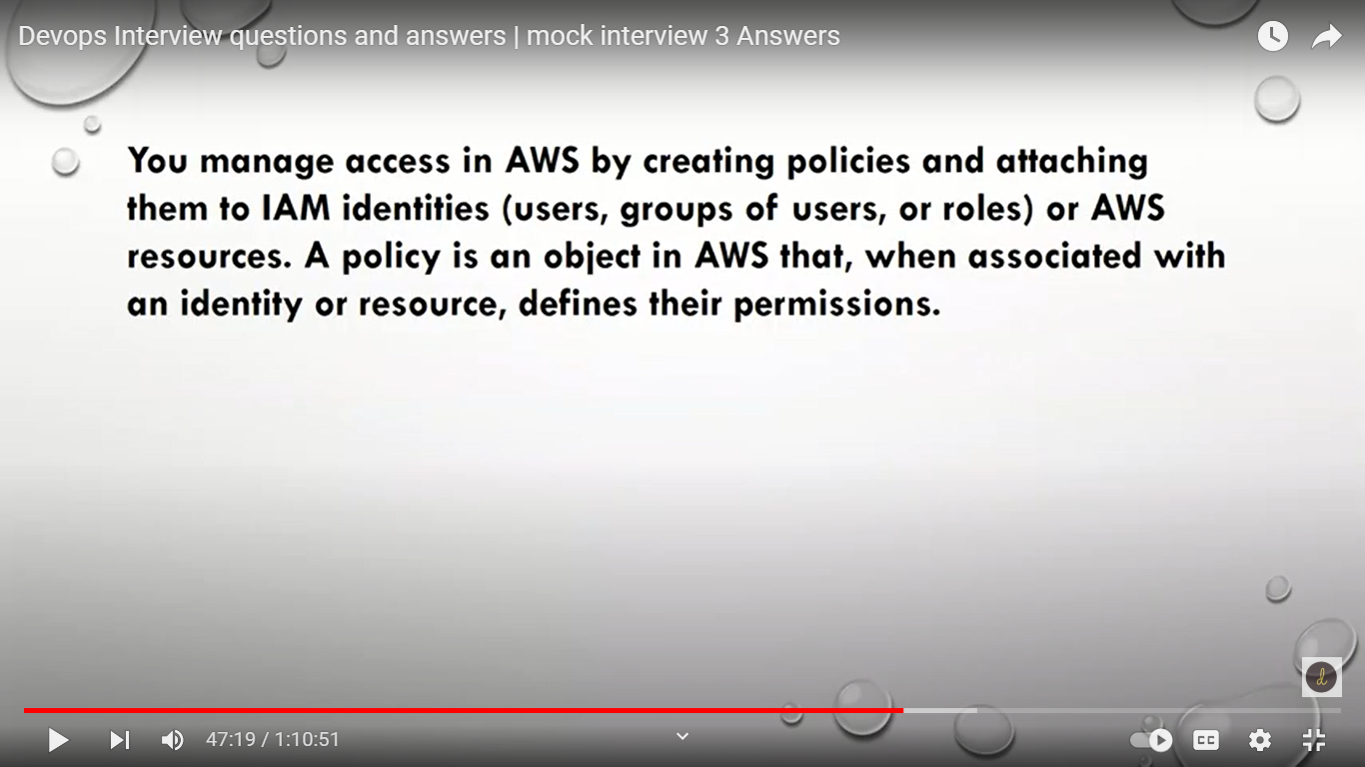

**18 Lets say I have 50 users , for all 50 users I need to provide same privileges how do it?**

Instead of manually attaching policy…. Create one group attach policy to that grp and attch users to that grp.

**19. I want to give programmatic access means They can access AWS services via api’s But should not be access AWS web console.**

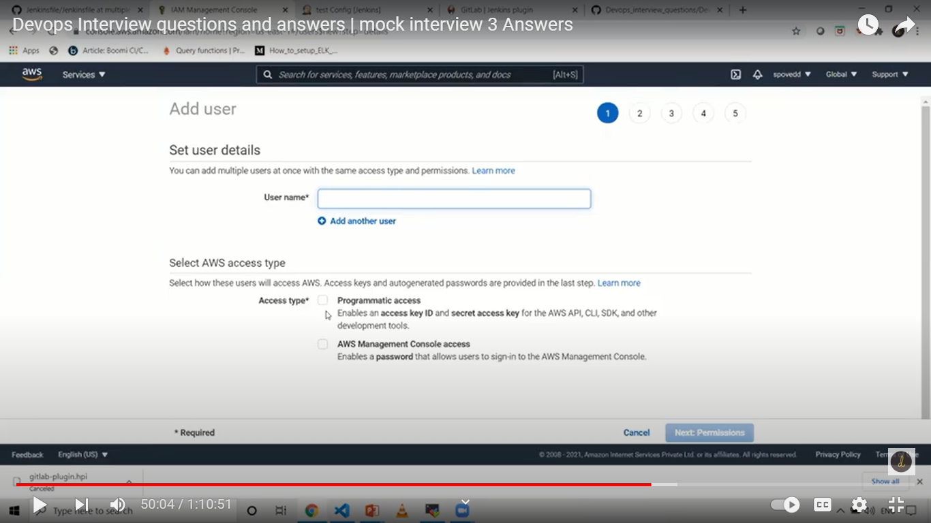

Programmatic access, AWS management console access

**20.As AMI is region specific I want create Machine with AMI which there in other Region is that possible?**

Ami s are region specific…. Ami templates ids are change accr to regn.

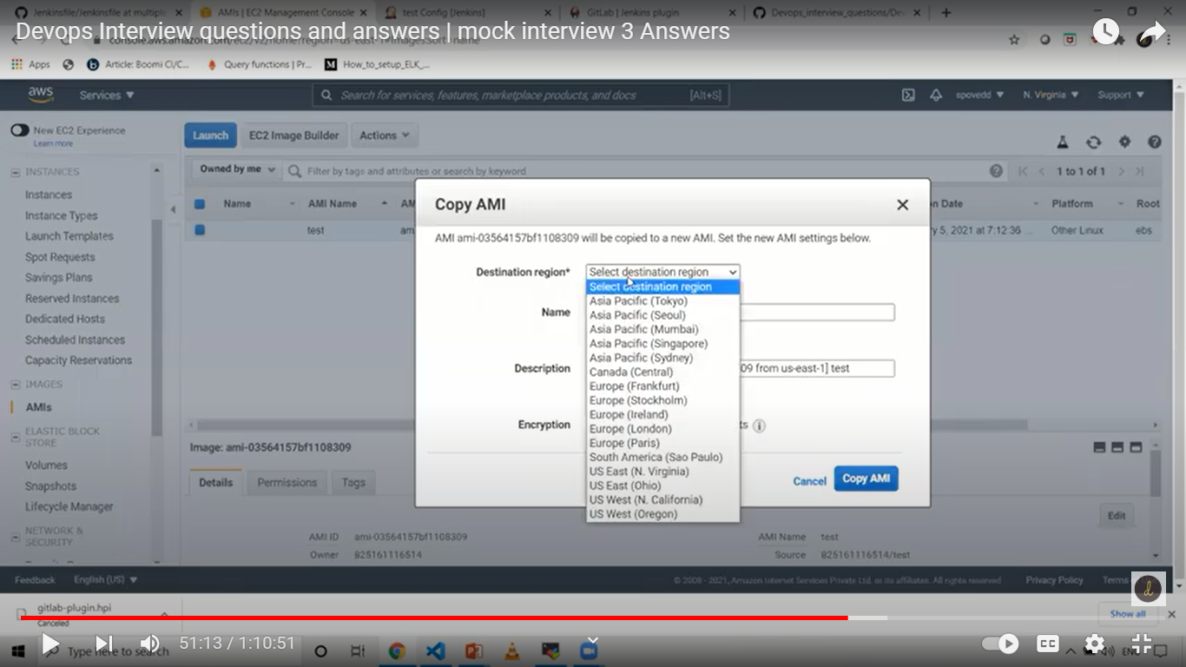

Test ami is default…. Copy ami to specific region.

**21.Why we need security groups? By default what is outbound rules?**

Bydefault having security group… or else we can create also.

to have security group – control inbound and outbound traffic.

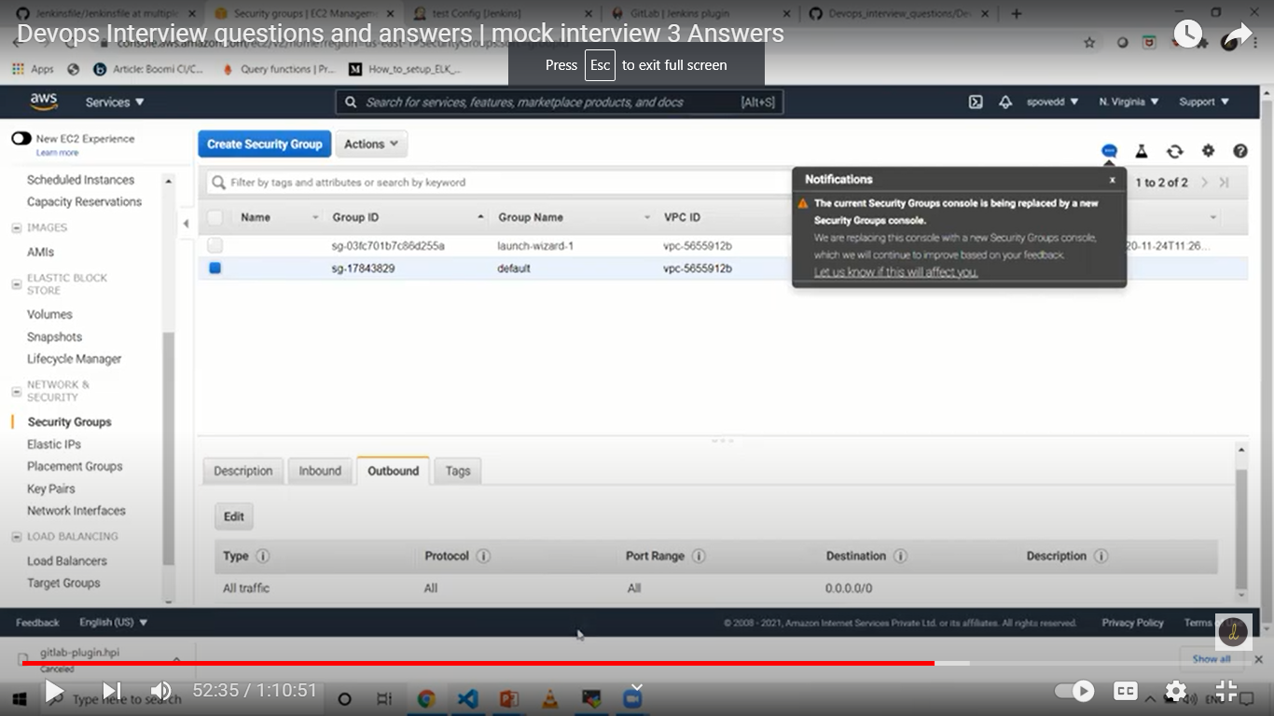

**22.What is VPC? Give a brief about VPC?**

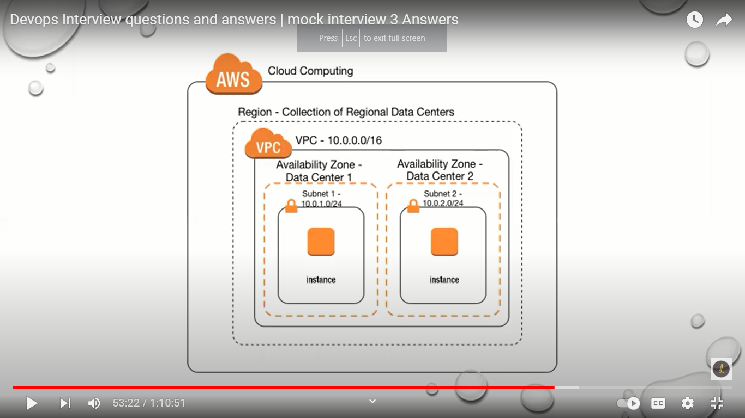

Private subnet – we cant access private subnet from anywhere

Public – create rout table, access internet gateway

Make all the compnents route it properly.

**23.Have you worked on Load balancers? If Yes, tell which load balancers you have used?**

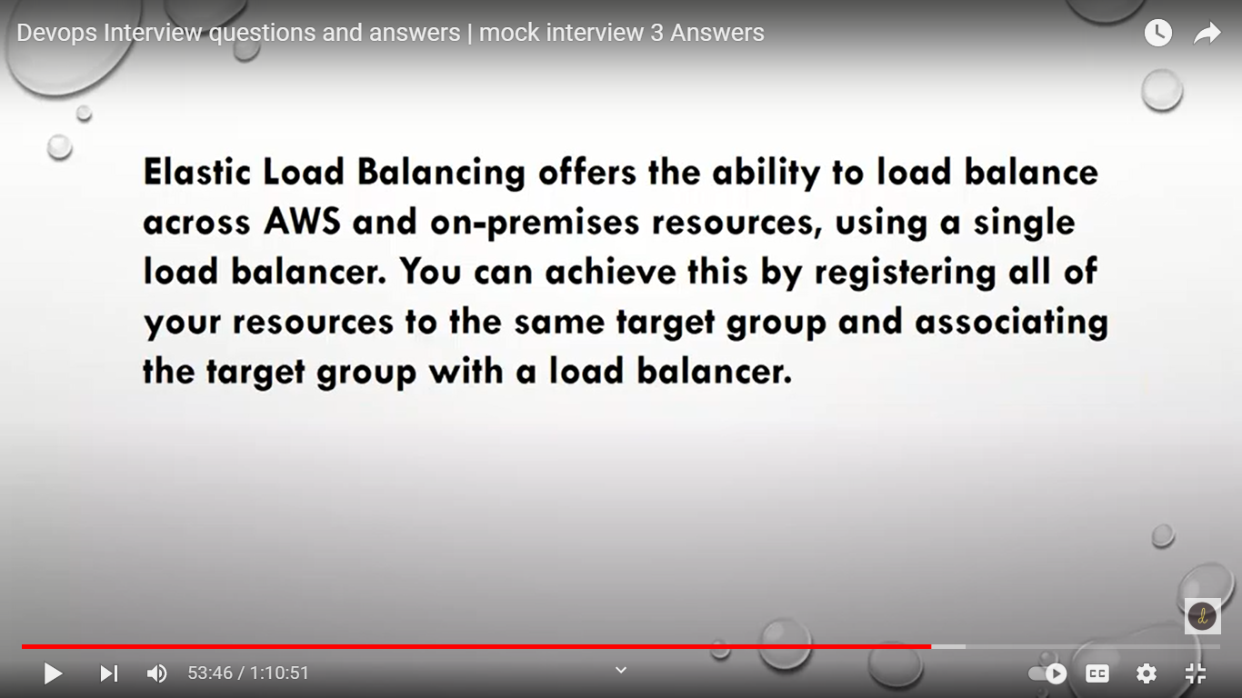

**24.Lets say I have created auto scaling rule when ever Load goes more than 60% create a new instance Currently I have 3 machines, 1st machine load is 62% , 2nd machine 30% and 3rd also 30%. Now will auto scale rule creates new machine ?**

**Jenkins**

**----------------------------------------------------------------------------------------------**

How to Downgrade plugins in Jenkins?

Plugin manager -> available -> click on selected plugin -> archives

Advanced -> upload plugin -> put .hpi file there

**15. Have you worked on Jenkinsfile? Can we use different nodes for each stage?**

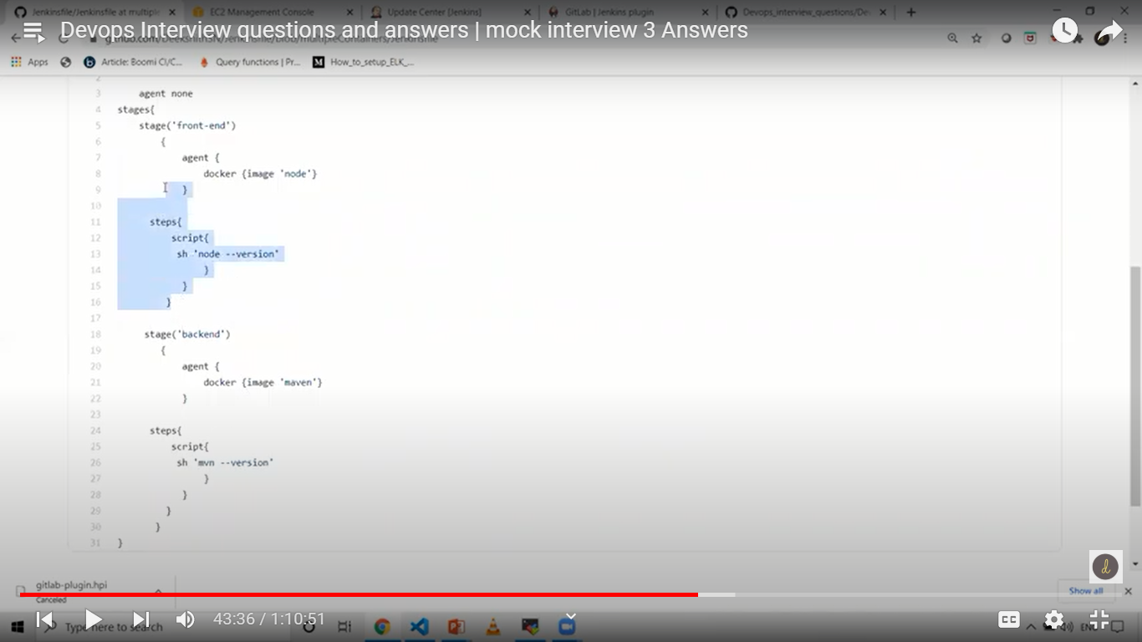

**16. Can you list few ways by which we can trigger our build in Jenkins? What is the difference between Build Periodically and Poll SCM?**

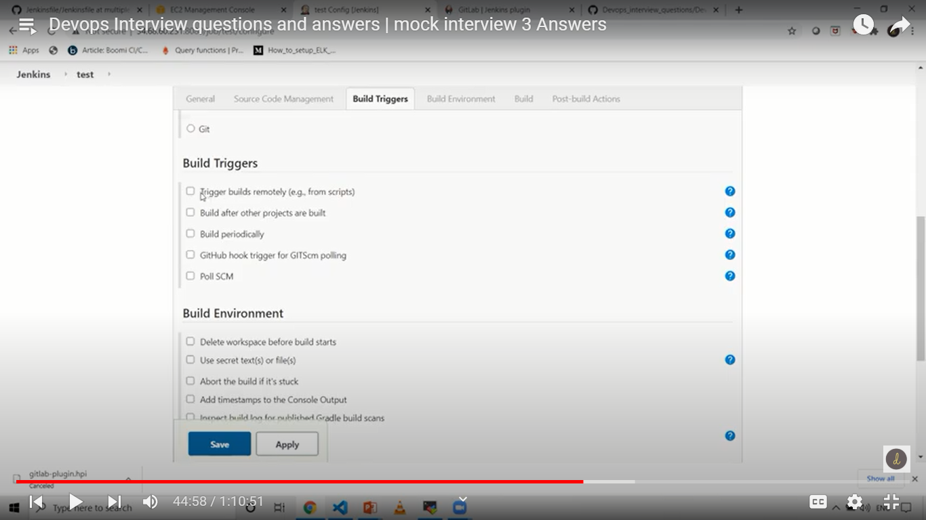

1) Github hook trigger for GITScm polling – enable webhook in github, once commit is done then it trigger automatically in jenkins dashboard.

2) Trigger builds remotely(e.g from script)

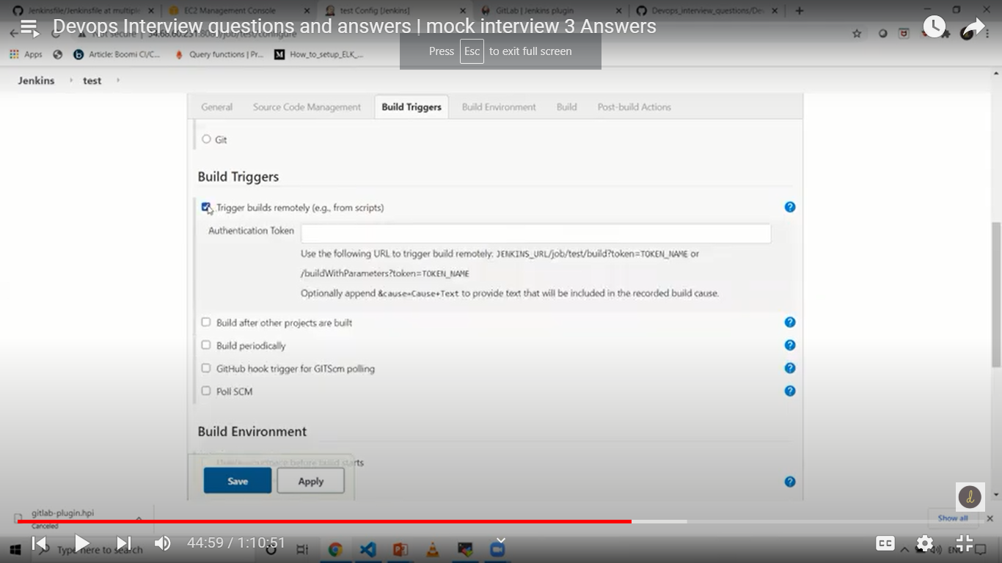

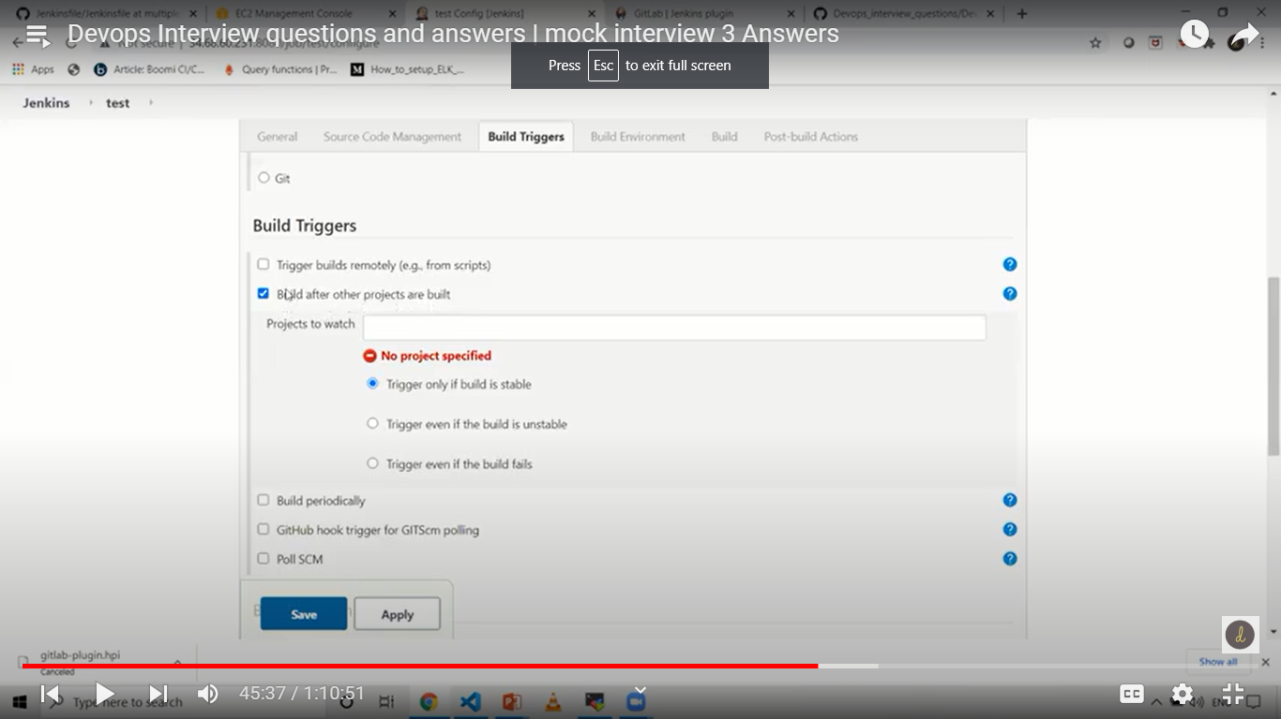

Called at upstream and downstream, one build after other

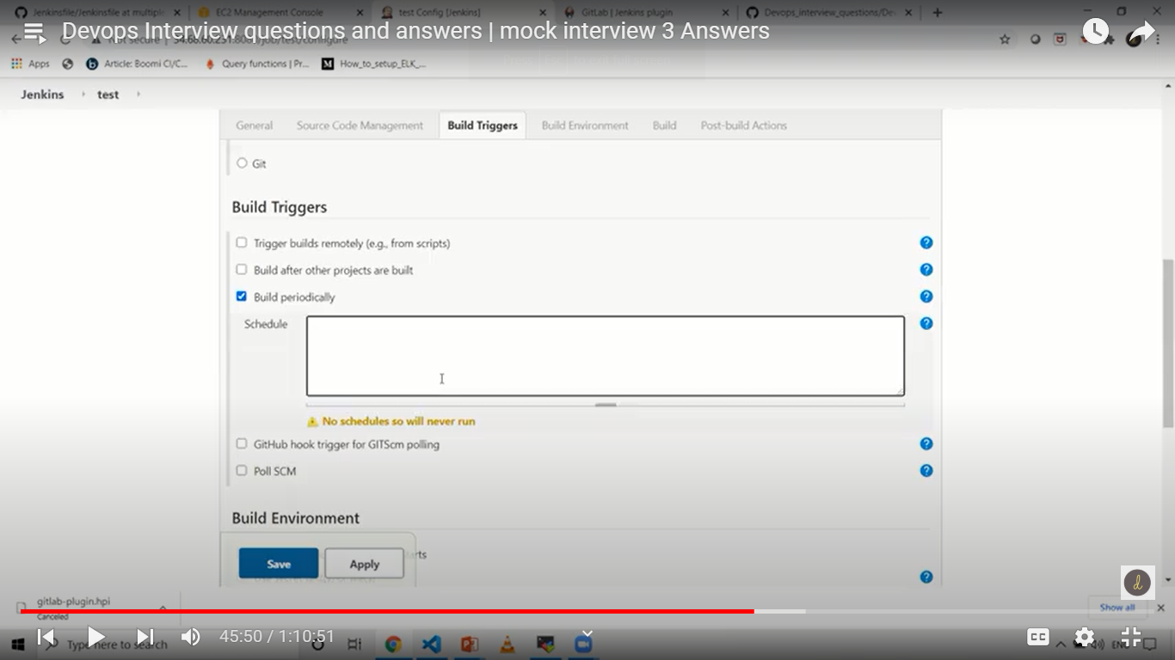

This is type of crontab….schedule build as per cron entry..

Poll SCM – it will first check, is there any change.. if yes then only build is trigger.

**Ansible**

-----------------------------------------------------------------------------------------------------------

**What is the best method to make your ansible YAML files reusable?**

Use roles in ansible

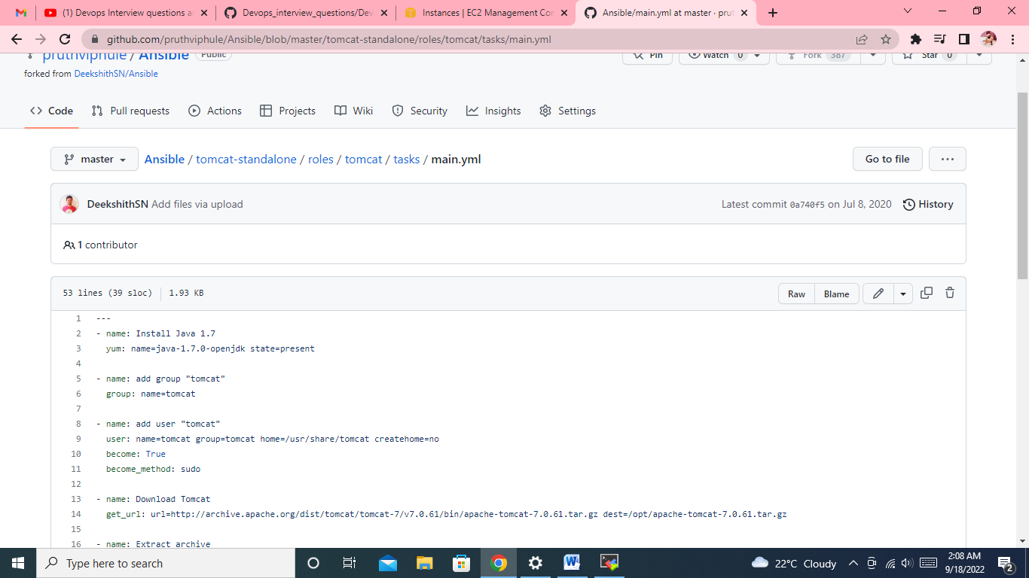

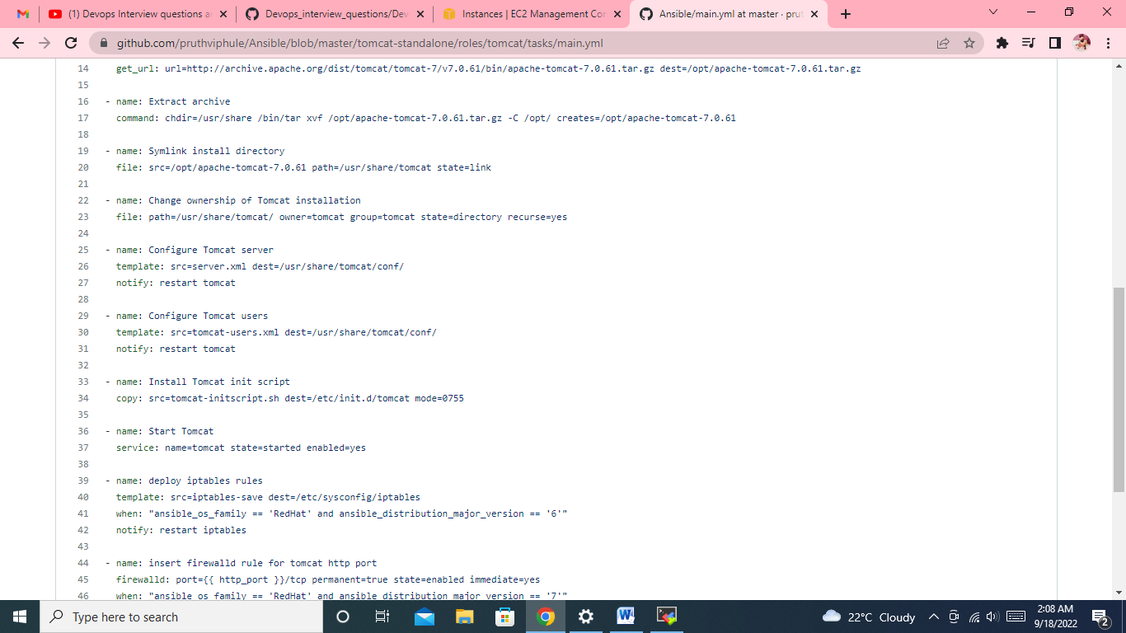

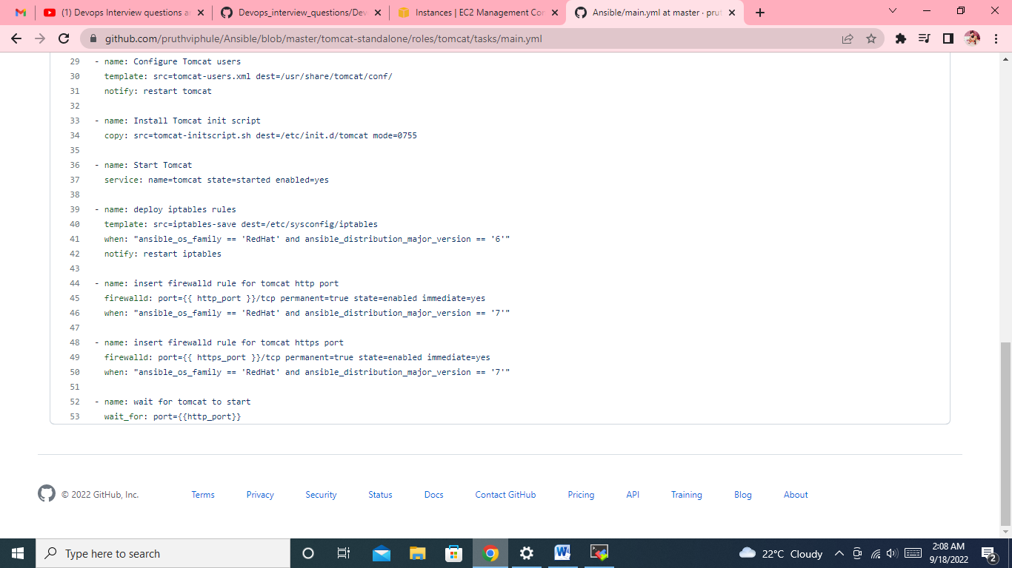

**26 . What is ansible vault and ansible tower?**

Ansible vault – any sensitive information.

Ansible Tower – if you want ansible playbook to run at particular time.

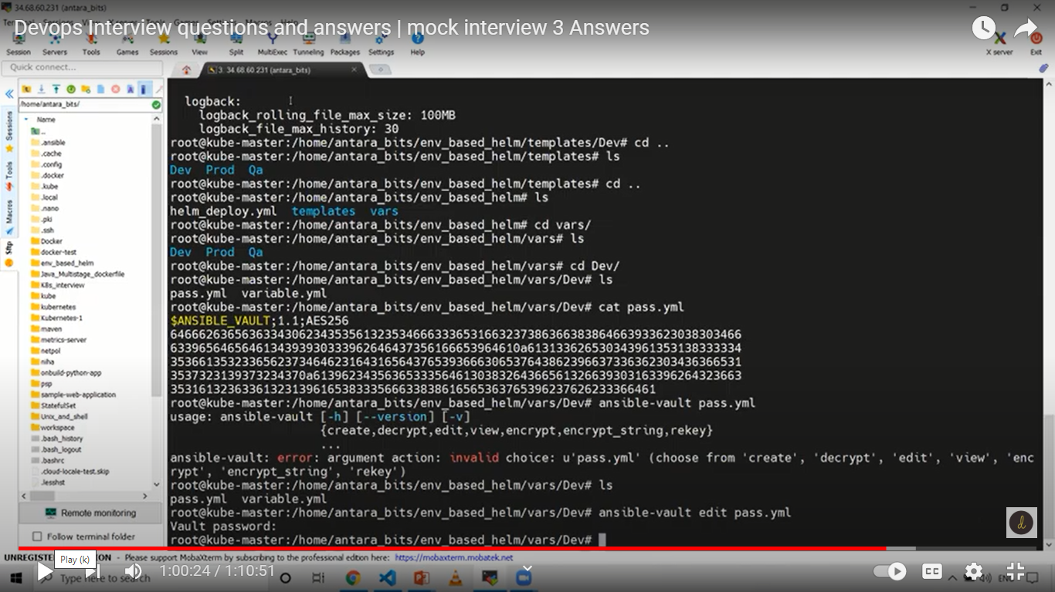

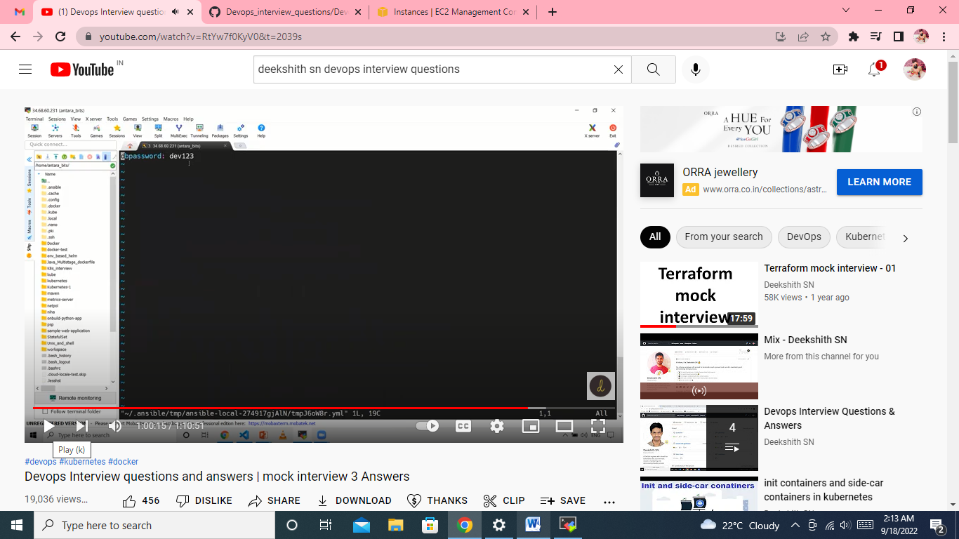

**27. Lets say I have playbook need to be run with Root user how would you do this?**

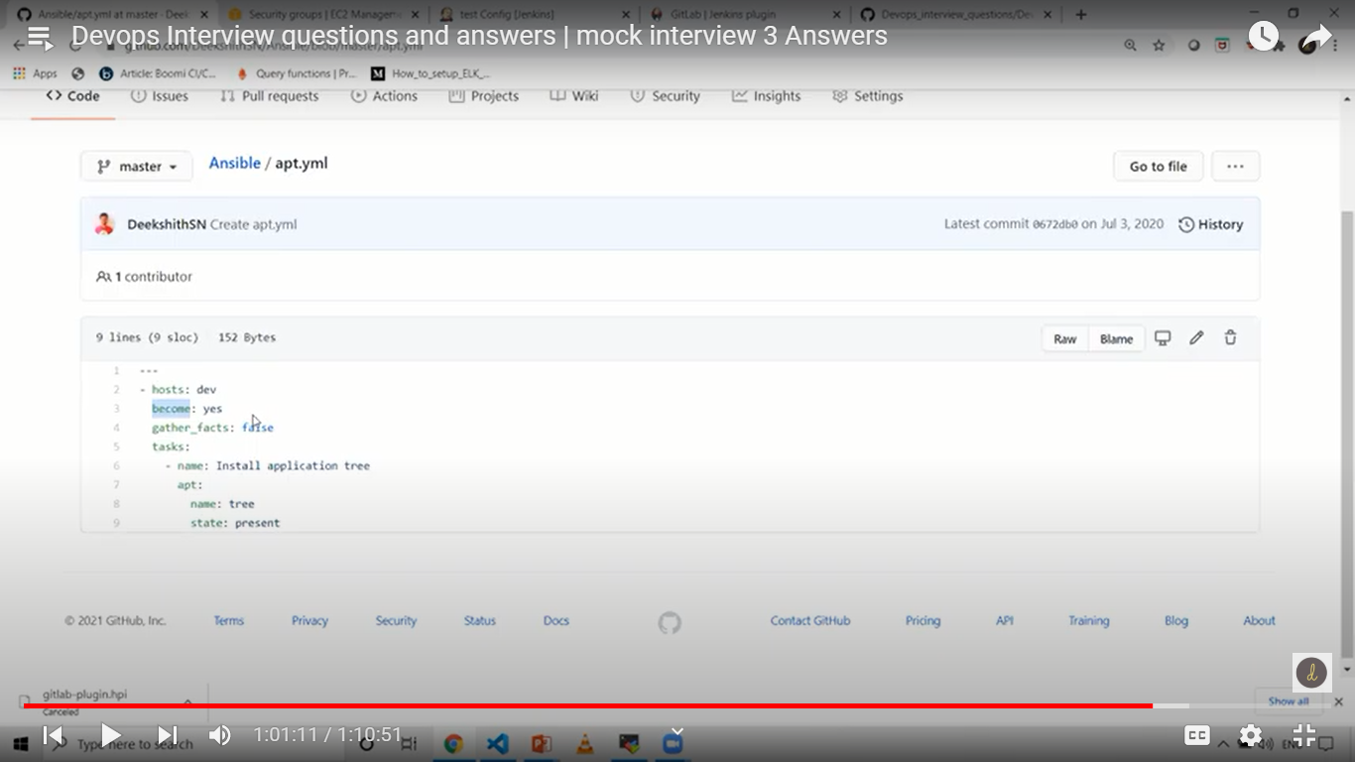

**By become yes**

**28.** **Difference between copy and fetch module?**

Copy module – copy from master to slave

Fetch module – copy from slave to master

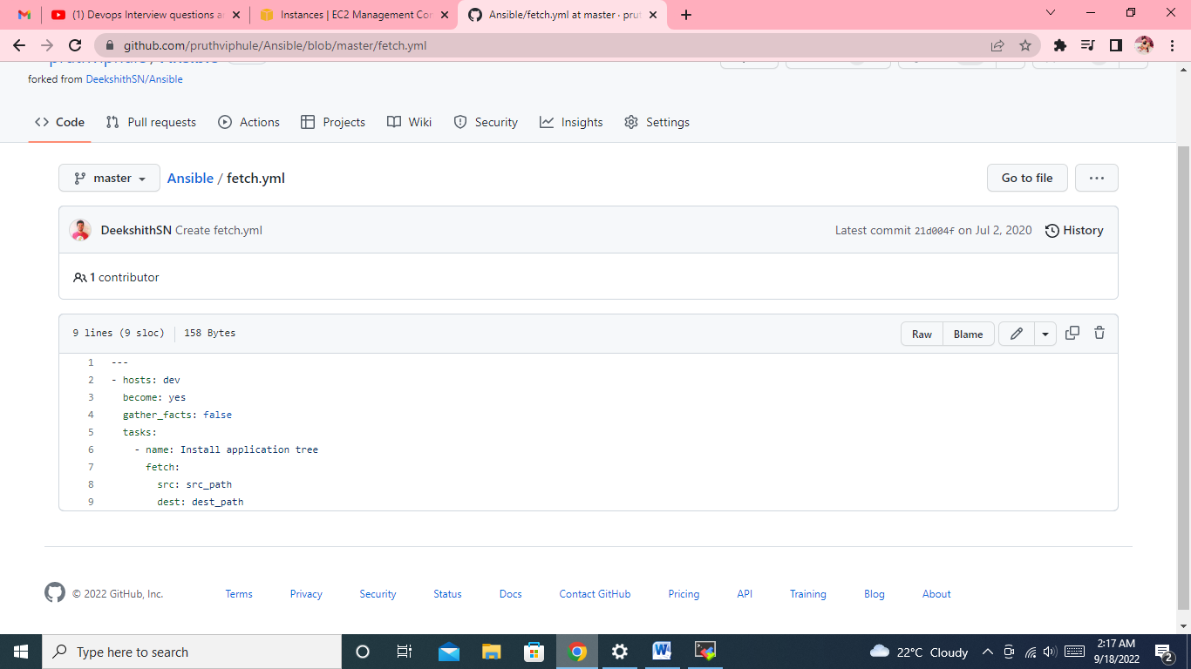

**Docker**

**Lets say I have 1 GB file that has to be sent to docker daemon, as its 1GB it will take muchtime and network too. By which option while building dockerfile we can send the fileIn better manner?**

Docker build – send a file to docker daemon

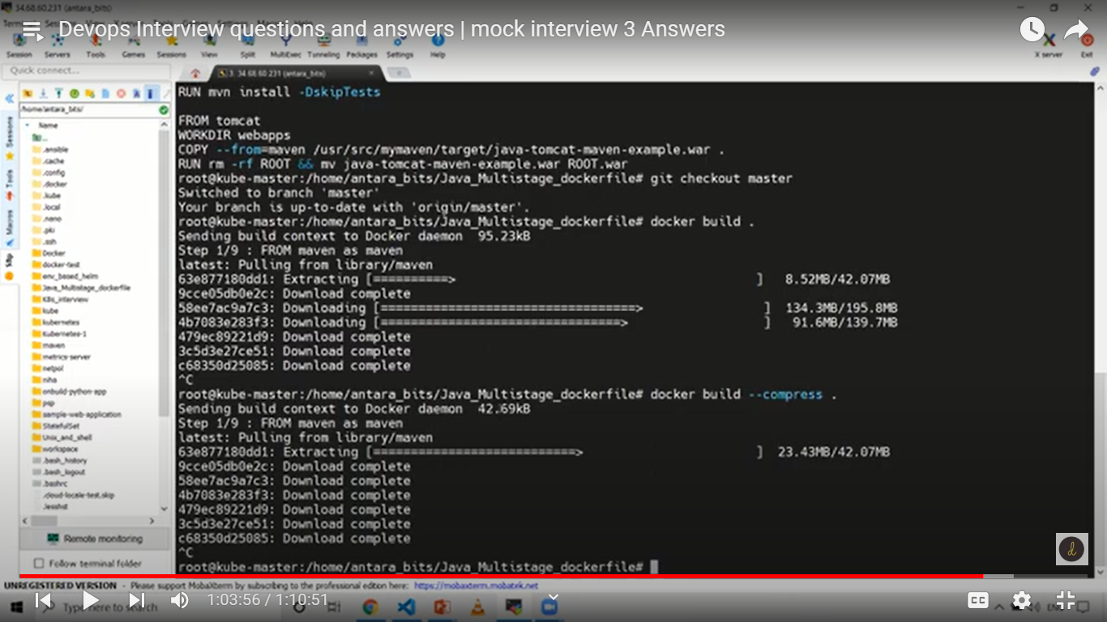

**30. What is the difference between ADD and COPY docker instructions in Dockerfile?**

Copying files from local to container context

Copy – same (always recommend

Add – extra features (tar file, urls)

**31. Command to remove to stopped and running Containers?**

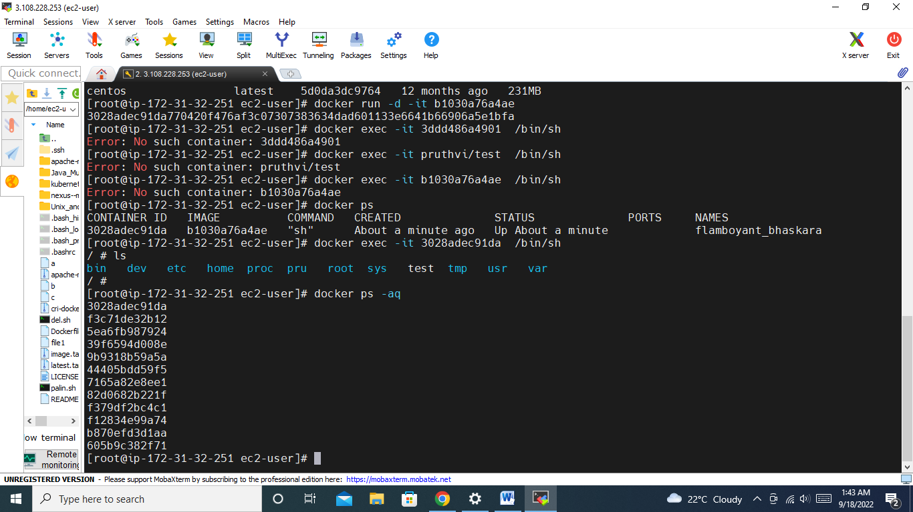

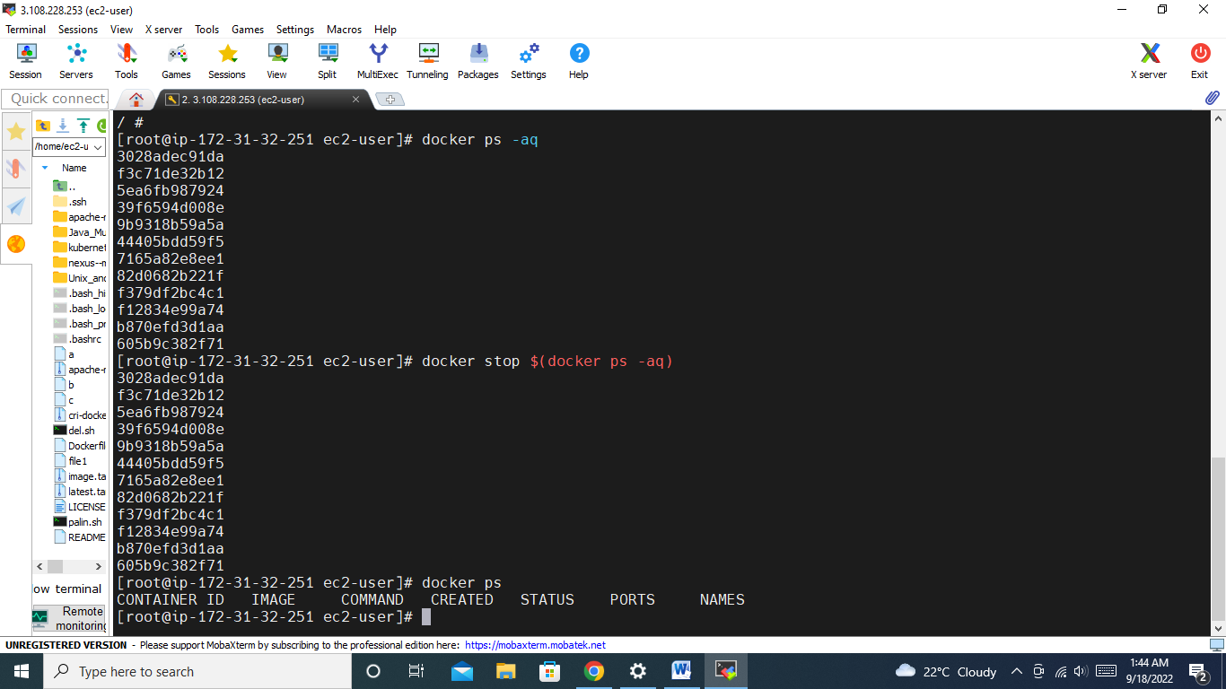

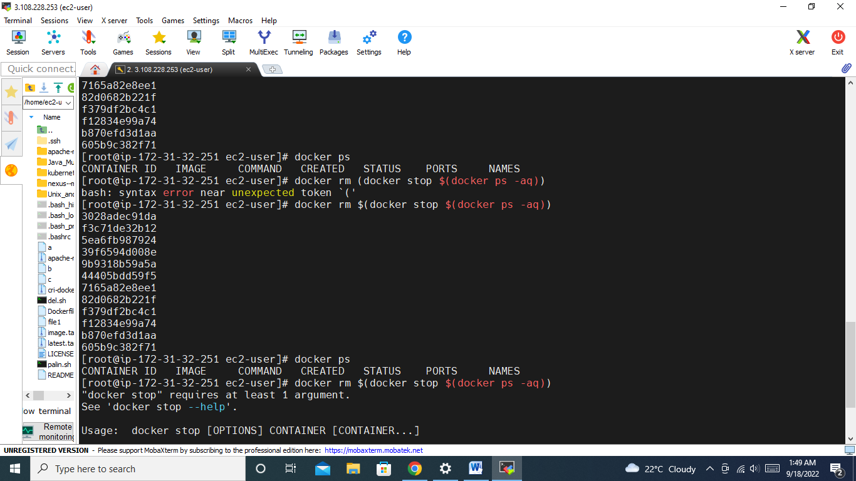

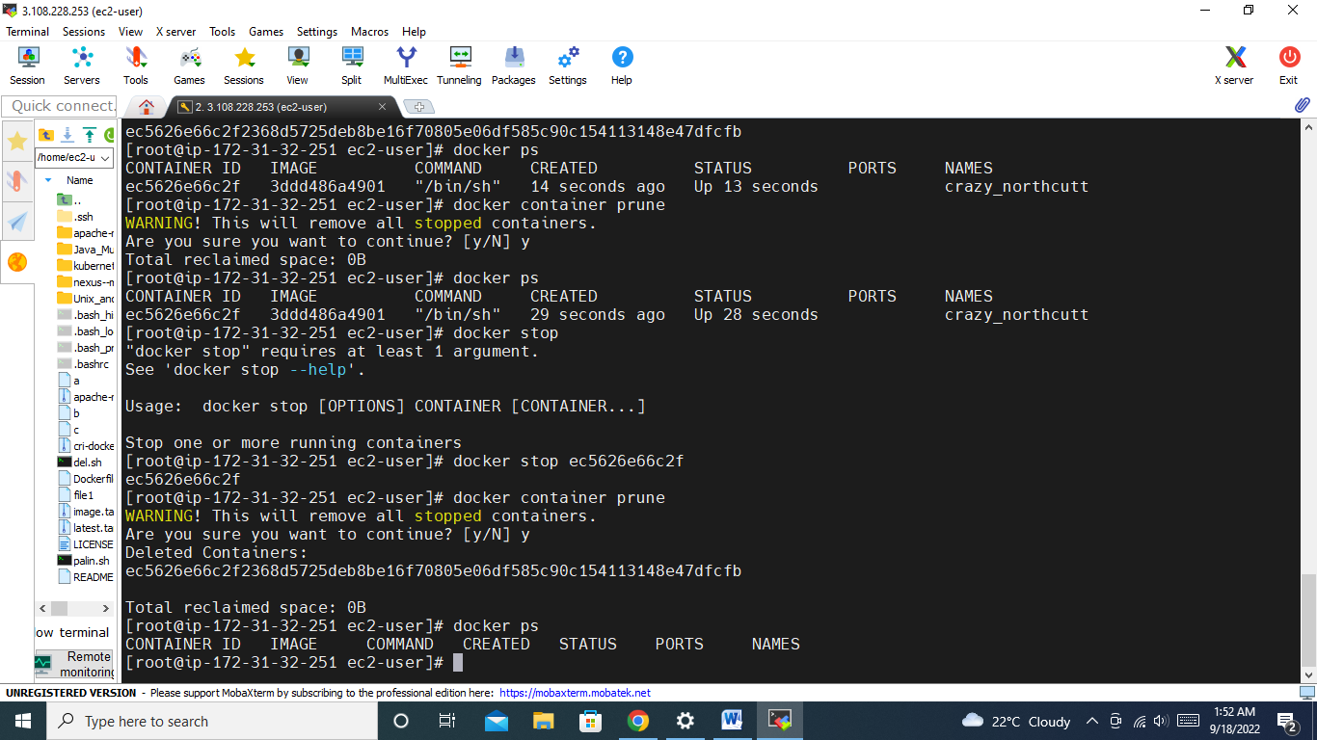

**32. Inside the container I did many changes like Creating, modifying and deleting file but I Wanted to check which files has been changed And what action has been taken what is the Command we need to use ?**

A – add, C – change, D- delete

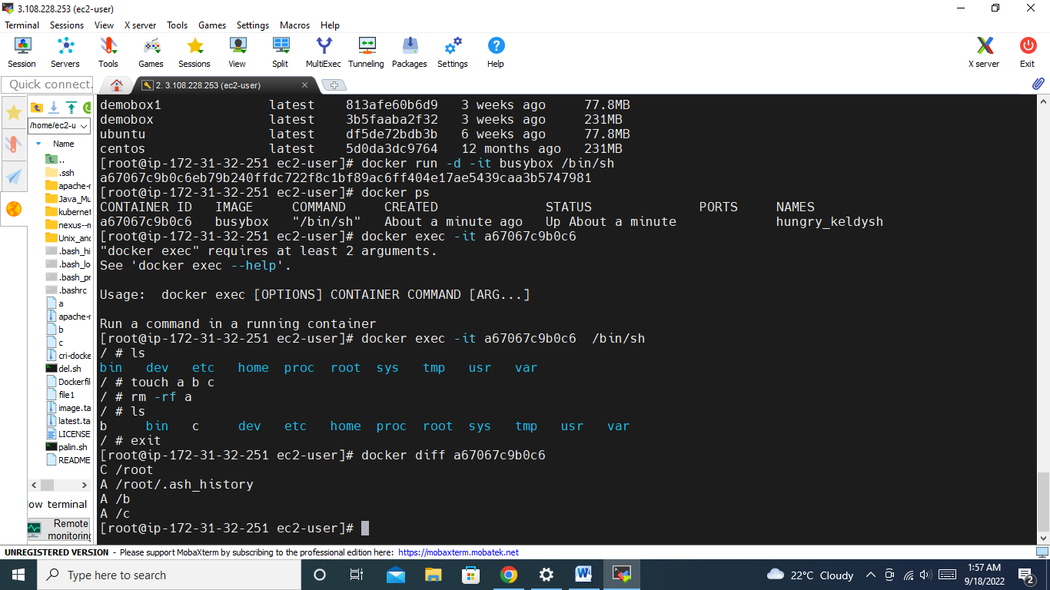

**Kubernetes**

**List objects you know in kubernetes?Give a brief about each object?**

Deployments, pods, replicaset, daemonset, services, ingress controller, network policy, pod security, jobs, cron jobs

**34. Command to list pods and deployments**

